AI FAQ ASSISTANT AI-powered FAQ and customer support automation.

Project documentation

Team leader : Kaviya. K

Team members : Poongavanam.V
: Elim.S
: Ramya.P
Department
- Sc Computer Science 3rd Year
Institution
Chellammal women's college

1. PROJECT INTRODUCTION
The AI FAQ Assistant is an intelligent question-answering system designed to provide quick and accurate answers to frequently asked questions. Traditional FAQ systems generally depend on users manually searching through a list of questions and answers. This process can be time-consuming, especially when the number of FAQs is large. The proposed AI FAQ Assistant uses Artificial Intelligence and Natural Language Processing techniques to understand user questions and provide relevant answers. Instead of searching manually through different categories, users can simply type their questions in natural language. The system processes the question, identifies the user's intent, searches the available FAQ knowledge base, and returns the most relevant response.
The system can be used in educational institutions, organizations, companies, customer-support departments, websites, and service portals. It reduces repetitive work for administrators and support staff while improving the accessibility of information for users. The main objective of this project is to develop a simple, efficient, and user-friendly AI-based FAQ system that can understand commonly asked questions and provide suitable responses.

Objectives
The major objectives of the AI FAQ Assistant are:
- To provide instant answers to frequently asked questions.
- To reduce the workload of support staff.
- To improve the speed of information retrieval.
- To provide a user-friendly conversational interface.
- To use AI/NLP techniques for understanding user queries.
- To maintain FAQ information in a structured database.
- To allow administrators to add, update, and delete FAQ information.
- To improve the overall user experience.
Scope of the Project
The AI FAQ Assistant can be implemented in educational institutions, hospitals, companies, e-commerce websites, government service portals, and other organizations where users frequently ask similar questions.
The system can be expanded in the future to support multiple languages, voice-based queries, document-based question answering, and advanced generative AI models.
2. ABSTRACT
The AI FAQ Assistant is an Artificial Intelligence-based application developed to automatically answer frequently asked questions from users. In many organizations, users repeatedly ask similar questions regarding services, procedures, timings, policies, products, and other general information. Handling such repetitive queries manually requires significant time and human resources.
The proposed system provides an automated solution by allowing users to enter questions through a simple conversational interface. The system analyses the user's query using Natural Language Processing techniques and identifies the relevant information from the FAQ knowledge base. Based on the identified question or intent, an appropriate answer is returned to the user.
The application consists of a frontend interface, backend processing system, AI/NLP module, and database. The frontend provides an easy-to-use interface for entering questions and viewing responses. The backend handles requests, processes queries, communicates with the database, and manages application logic. The database stores FAQs, categories, users, queries, responses, and feedback.
The system reduces response time, improves accessibility, minimizes repetitive manual work, and provides consistent answers. It can be further enhanced with advanced Large Language Models, multilingual support, voice interaction, analytics, and personalized responses.
3. CASE STUDY
3.1 Background
Consider an educational institution where students frequently ask questions regarding admission procedures, examination schedules, fees, attendance, departments, certificates, library timings, hostel facilities, and placement activities.
At present, students may obtain this information by visiting the office, contacting staff members, checking notices, or searching through the institution's website. When the same questions are repeatedly asked by many students, staff members have to spend considerable time providing identical answers. An AI FAQ Assistant can solve this problem by providing an automated question-answering service.
3.2 Existing Scenario
In the existing system:
- Users manually search for information.
- FAQs may be distributed across multiple web pages.
- Support staff answer repeated questions.
- Response time depends on staff availability.
- Users may have difficulty finding the correct information.
- Updating information may require manual changes in multiple locations.
3.3 Proposed Scenario
In the proposed system, users interact with an AI FAQ Assistant.
For example, a student can enter:
User: "What is the procedure for applying for a bonafide certificate?"
The system processes the question and searches its FAQ knowledge base.
AI FAQ Assistant: "Students can apply for a bonafide certificate through the student portal or by contacting the administrative office. Required details include student ID and department information."
This provides an immediate response without requiring manual assistance.
3.4 Benefits of the Case Study
The system:
- Saves staff time.
- Provides 24/7 assistance.
- Reduces repetitive questions.
- Improves information accessibility.
- Provides consistent answers.
- Makes the support process more efficient.
4. PROBLEMS AND SOLUTIONS
4.1 Problem: Repeated Questions
Users frequently ask the same questions to support staff.
Solution
The AI FAQ Assistant stores frequently asked questions and their corresponding answers. Once a question is processed, the system can provide the stored answer automatically.
4.2 Problem: Manual Information Search
Users may need to search multiple pages to find the required information.
Solution
The user can directly enter a question in the chatbot interface. The system searches the FAQ knowledge base and returns the relevant information.
4.3 Problem: Slow Response
Manual support depends on staff availability.
Solution
The automated assistant can provide responses immediately after receiving the query.
4.4 Problem: Difficulty Understanding User Questions
Users may ask the same question using different words.
For example:
- "When does the college open?"
- "What are the college working hours?"
- "Tell me the college timings."
All three questions can represent a similar intent.
Solution
Natural Language Processing can be used to identify the meaning or intent behind the user's query rather than depending only on exact keyword matching.
4.5 Problem: FAQ Maintenance
Old information can become outdated.
Solution
An administrator module can be provided to add, edit, and delete FAQ records.
4.6 Problem: Lack of Feedback
A system may not know whether users received useful answers.
Solution
The application can provide a feedback option such as "Helpful" and "Not Helpful." This information can be used to improve the FAQ database.
5. SOFTWARE REQUIREMENTS
The following software components can be used for developing the AI FAQ Assistant.
Software| Purpose
Windows/Linux| Operating System
Python| Backend and AI development
Flask/FastAPI| Backend API development
HTML| Web page structure
CSS| User interface styling
JavaScript| Frontend interaction
MySQL| Database management
VS Code| Development environment
Git| Version control
Web Browser| Application execution
NLP Libraries| Query processing
5.1 Operating System
The application can be developed and executed on Windows, Linux, or macOS.
5.2 Programming Language
Python can be used for backend development and AI/NLP processing because it provides extensive libraries for machine learning, text processing, API development, and database connectivity.
5.3 Frontend Technologies
HTML, CSS, and JavaScript can be used to create an interactive and responsive chatbot interface.
5.4 Backend Framework
Flask or FastAPI can be used to create REST APIs that connect the frontend, AI processing module, and database.
5.5 Database
MySQL can be used to store FAQ information, user queries, responses, categories, and feedback.
6. HARDWARE REQUIREMENTS
The system does not require high-end hardware for basic FAQ processing.
Component| Minimum Requirement
Processor| Intel Core i3 or equivalent
RAM| 4 GB
Storage| 10 GB available space
Display| 1366 × 768 or above
Keyboard| Standard keyboard
Mouse| Standard mouse
Network| Internet/LAN connection
Recommended Configuration
For development and testing, the following configuration is recommended:
- Intel Core i5 or equivalent processor.
- 8 GB RAM.
- 256 GB SSD.
- Stable internet connection.
- Modern web browser.
If a large AI model is hosted locally, additional RAM and GPU resources may be required.
7. PROJECT ARCHITECTURE
The AI FAQ Assistant follows a layered architecture.
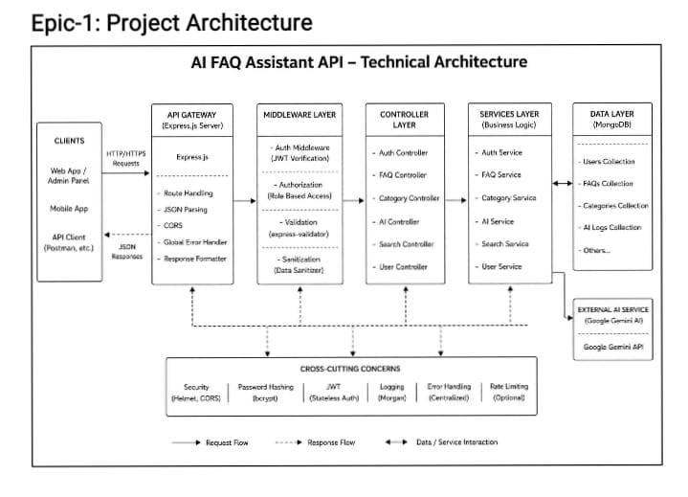
Architecture components
7.1 User Interface
The user interface allows users to enter questions and view responses. It provides a simple chat-like environment.
7.2 Backend API
The backend receives the user's question and controls communication between the frontend, AI module, and database.
7.3 AI/NLP Module
The AI/NLP module analyzes the user's question and identifies the relevant FAQ or intent.
7.4 Database
The database stores FAQ information and other application data.
7.5 Response Module
The response module prepares the final answer and sends it back to the frontend.
8. ARCHITECTURE DEFINITION
The architecture is divided into multiple logical layers.
Presentation Layer
This layer represents the frontend application. Users interact with the system through this layer.
Application Layer
The backend handles requests, validates inputs, manages business logic, and communicates with other modules.
AI Processing Layer
This layer processes natural-language questions. It can perform text cleaning, keyword extraction, similarity matching, intent detection, or AI-based response generation.
Data Layer
The data layer contains the FAQ database. It stores questions, answers, categories, user queries, and feedback.
Response Flow
1. User enters a question.
2. Frontend sends the question to the backend.
3. Backend validates the request.
4. AI/NLP module processes the question.
5. Relevant FAQ information is retrieved.
6. The response is generated.
7. Backend sends the response to frontend.
8. User sees the answer.
9. ER DIAGRAM
The Entity Relationship Diagram represents the logical structure of the database.
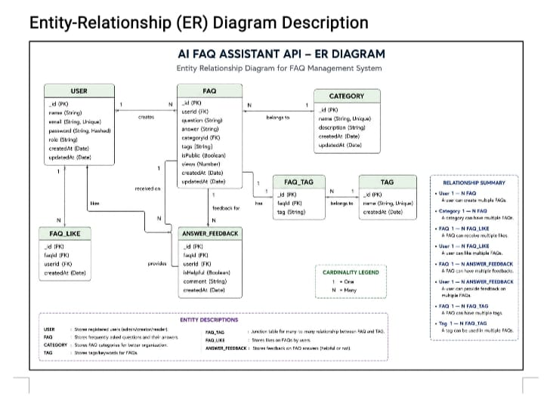
10. ER DIAGRAM DEFINITION
User Entity
The User entity stores information about users interacting with the system.
Attributes:
- user_id
- name
- email
- password
The "user_id" acts as the primary key.
FAQ Entity
The FAQ entity stores frequently asked questions and their answers.
Attributes:
- faq_id
- category_id
- question
- answer
- keywords
The "faq_id" is the primary key.
Category Entity
The Category entity organizes FAQs into different categories.
Examples:
- Admission
- Examination
- Fees
- Library
- Hostel
- Placement
- General Information
Query Entity
The Query entity stores questions entered by users.
Attributes:
- query_id
- user_id
- question
- response
- created_at
Feedback Entity
The Feedback entity stores user feedback regarding the response.
Attributes:
- feedback_id
- query_id
- rating
- comments
11. KEY FEATURES
11.1 AI-Based Question Answering
The system processes natural-language questions and provides relevant answers.
11.2 FAQ Search
Users can search the FAQ knowledge base through natural-language queries.
11.3 User-Friendly Interface
The application provides a simple conversational interface.
11.4 Fast Response
The system automatically processes queries and provides responses with minimal delay.
11.5 Category Management
FAQs can be organized according to categories.
11.6 Admin Management
Administrators can add, modify, and remove FAQ records.
11.7 Feedback System
Users can provide feedback on generated responses.
11.8 Query History
The application can maintain previous user queries for analysis and future improvements.
11.9 Scalable Architecture
The architecture can be extended to support advanced AI models and larger databases.
11.10 24/7 Availability
Since the system is automated, it can provide assistance without depending on support staff working hours.
12. ROLES AND RESPONSIBILITIES
Team Member 1 – Frontend Developer
Responsibilities:
-Design the user interface.
-Develop chatbot screens.
-Implement HTML/CSS/JavaScript.
-Connect frontend with backend APIs.
-Ensure responsive design.

Team Member 2 – Backend Developer
Responsibilities:
-Develop backend APIs.
-Implement application logic.
-Handle user requests.
-Connect frontend and database.
-Implement error handling.

Team Member 3 –Database Developer
Responsibilities:
-Design database schema.
-Create tables.
-Establish relationships.
-Implement CRUD operations.
-Maintain database consistency.

Team Member 4 –AI/NLP Developer
Responsibilities:
-Implement query.
-processing logic.
-Develop FAQ matching.
-Integrate AI/NLP models.
-Improve response accuracy.
-Test different user queries.

Team Member 5 –Testing and Documentation
Responsibilities:
-Prepare test cases.
-Perform functional testing.
-Identify bugs.
-Verify expected results.
-Prepare project documentation.

13. USER FLOW
The user flow explains how a user interacts with the application.
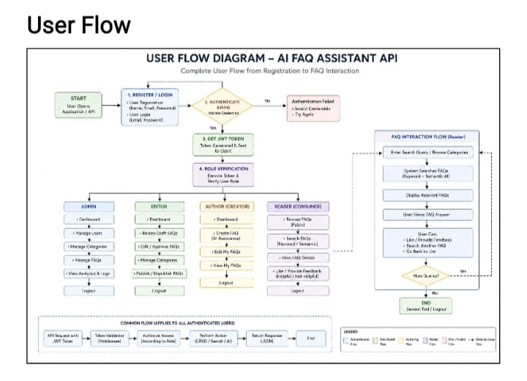
User Flow Explanation
First, the user opens the AI FAQ Assistant. The user enters a question in the chat interface and submits it. The frontend sends the question to the backend API. The backend passes the query to the AI/NLP module. The module analyzes the query and searches for the most relevant FAQ information. If a suitable answer is found, the system returns the response to the user. If the system cannot find a suitable answer, it can display a default response requesting the user to rephrase the question or contact an administrator. The user can then provide feedback about the response.
14. PROJECT SETUP AND CONFIGURATION
Creating Project Folder
Create a new folder with your <project name>.
Inside that folder, create a new subfolder named src.
Now open that folder in VS Code.
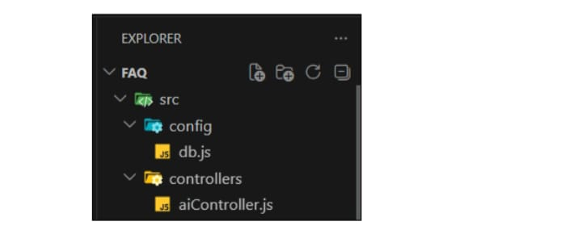
Server Setup (npm init)
Open your root folder terminal in VS Code and run:Bash
npm init -y
npm install express mongoose dotenv cors jsonwebtoken bcrypt @google/genai
File and Folder Structure Matrix
Plaintext
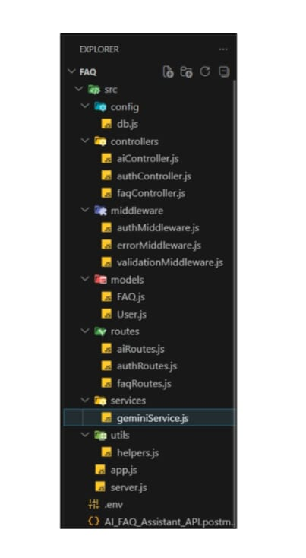
Epic 3: Backend Development
Core System Script Implementations
1.Gateway Server Node (src/server.js)
This main entrance mechanism aggregates environment variables, triggers database listeners, and binds network listeners to active environment ports:
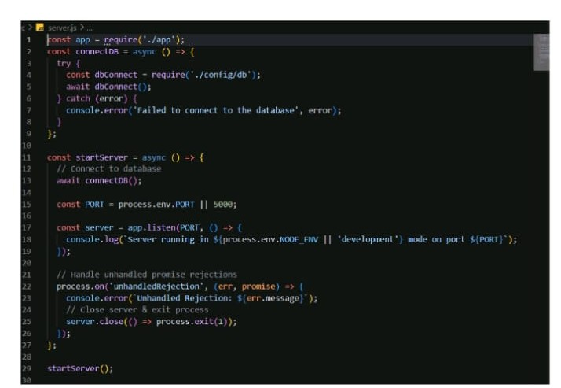
1.Gateway Express Setup (src/app.js)
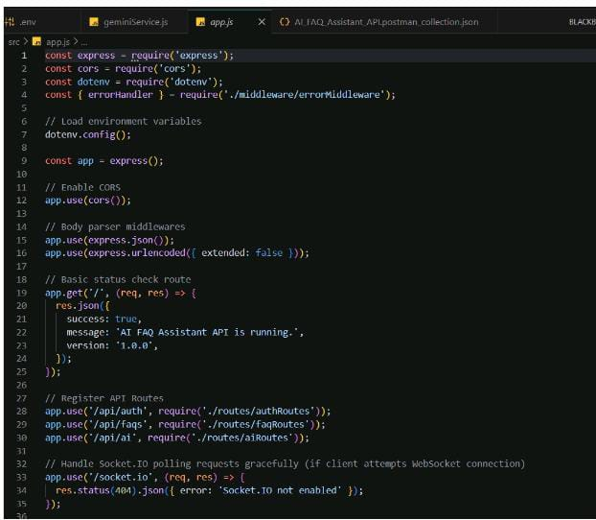
3. Security Access Middleware (src/middleware/authMiddleware.js)
Intercepts incoming target queries, extracts transmission header authorization records, and validates token identity context claims:
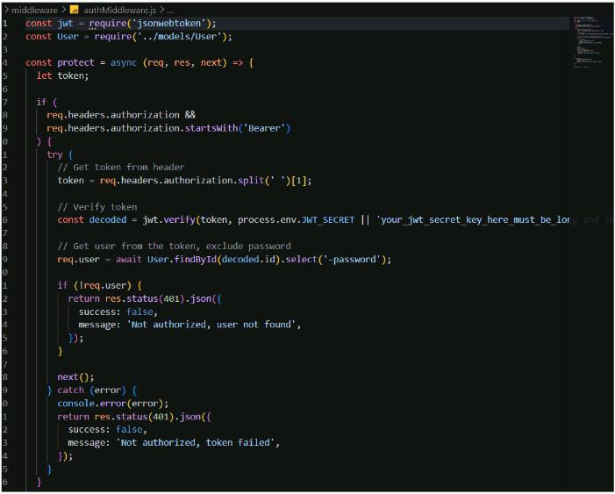
4. Centralized Error Handler Middleware (src/middleware/errorMiddleware.js)
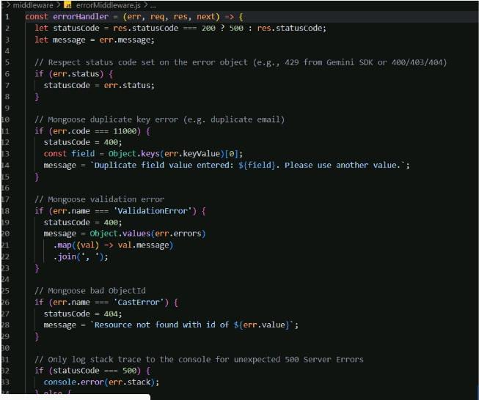Epic 4: Database Configuration
Mongoose Schema Definitions
1.Identity Resource Document Schema (src/models/User.js)
Enforces profile field criteria validations and hooks password hashing steps prior to user document persistence:
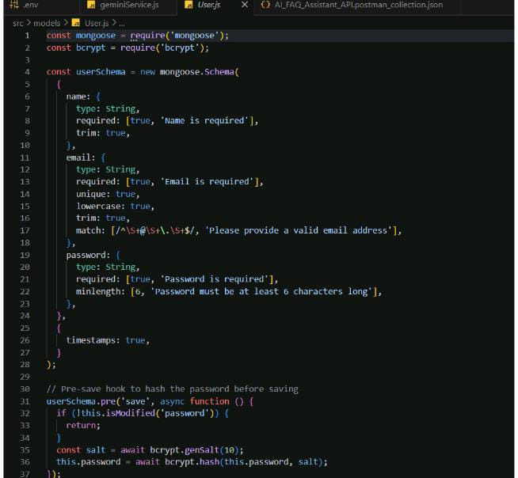
2. FAQ Resource Document Schema (src/models/FAQ.js)
Models core properties and maps a distinct relational reference link back to the source creator document:
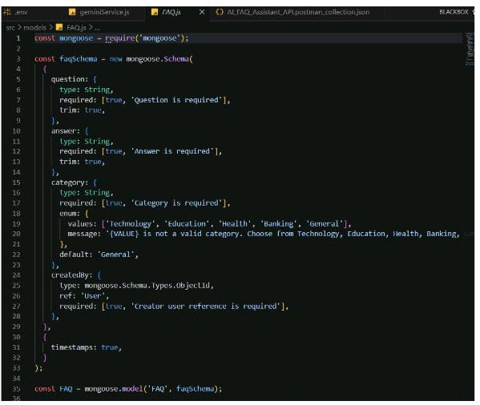
API Router Interface Endpoints
1.Public Authentication Operations (src/routes/authRoutes.js)
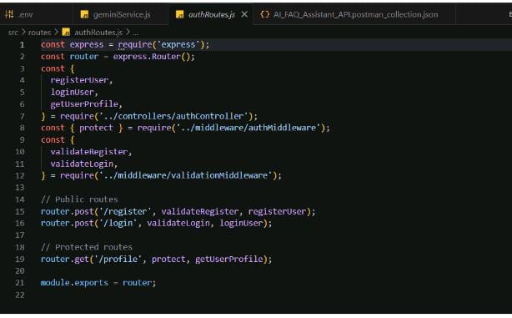
2. Protected FAQ Operations (src/routes/faqRoutes.js)
JavaScript
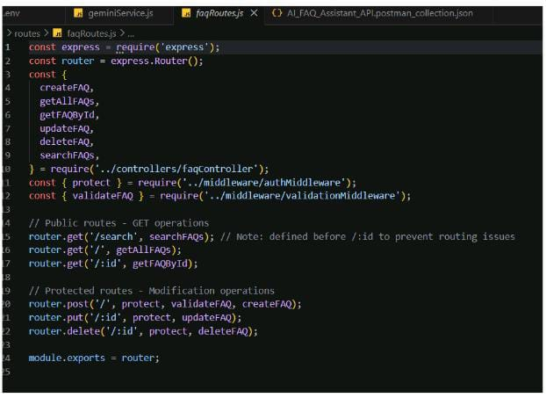
3. AI Automation Operations (src/routes/aiRoutes.js)
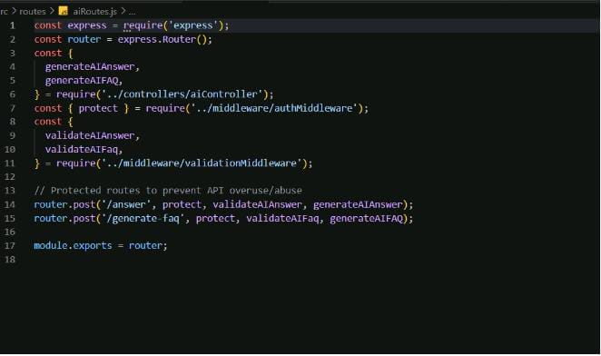
15. BACKEND DEVELOPMENT
The backend acts as the central component of the application.
15.1 API Development
The backend provides APIs for:
- Submitting user questions.
- Retrieving FAQ information.
- Adding FAQs.
- Updating FAQs.
- Deleting FAQs.
- Managing categories.
- Storing feedback.
- Retrieving query history.
16. DATABASE CONFIGURATION
MySQL can be used as the database management system.
Database Name
ai_faq_assistant
Main Tables
Users Table
Categories Table
FAQs Table
Queries Table
Feedback Table

17. PROJECT EXECUTION
Running the API Application
Install Postman or ThunderClient (VS Code extension).
Start the backend development server environment parameters:
Bash
npm run dev
API Testing Specification Demo
To verify operational structural integrity via execution endpoints, map endpoints using the configurations below:
1. Identity Onboarding Path Registration
Route: POST /api/auth/register
Access: Public
Payload Request Body JSON:
JSON
{
"name": "kaviya",
"email": "kaviya1@gmail.com",
"password": "kaviya@2007"}
2.Profile Login Verification Quey
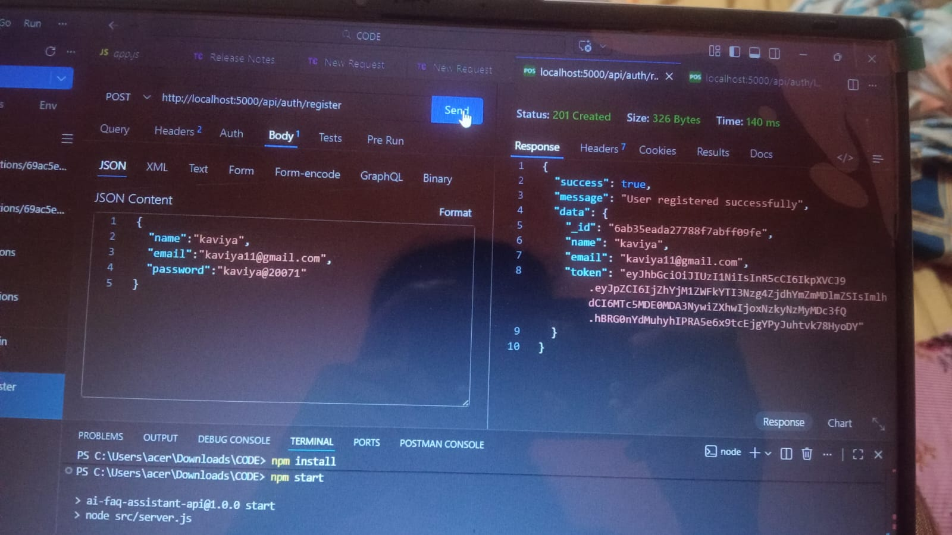
Route: POST /api/auth/login
Access: Public
Payload Request Body JSON:
JSON
{
"email": "kaviya@gmail.com",
"password": "kaviya@2007"}
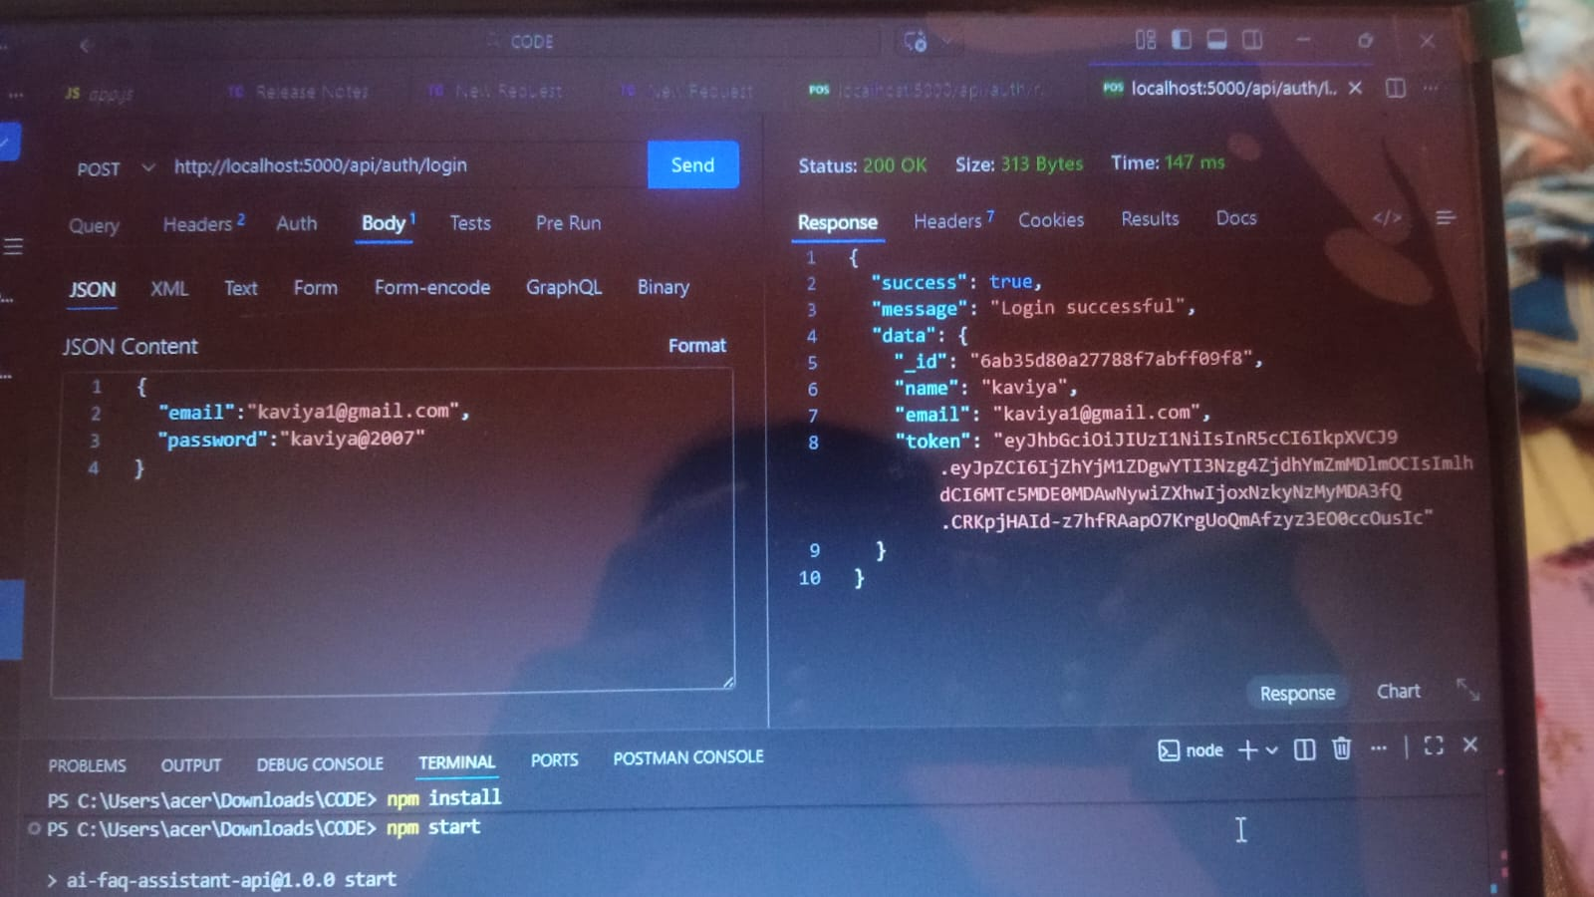
3. Resource Entity Creation (FAQ)
Route: POST /api/faqs
Access: Private (Bearer <JWT Token>)
Payload Request Body JSON:
JSON
{
"question": "what is mongodb",
}

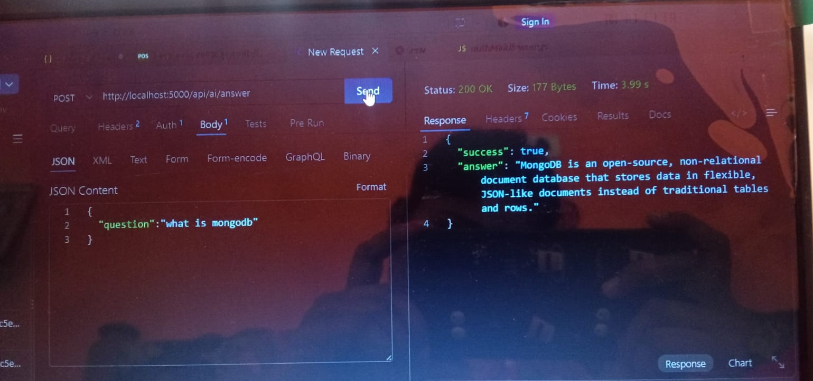
18. TESTING
19. CONCLUSION
The AI FAQ Assistant provides an effective solution for automating frequently asked questions. The system combines a user-friendly interface, backend APIs, database management, and Artificial Intelligence/Natural Language Processing to provide quick and relevant responses. Traditional FAQ systems require users to manually search through large amounts of information. The proposed system simplifies this process by allowing users to ask questions naturally and receive suitable answers automatically. The application can reduce repetitive work, improve response time, and make information more accessible. The modular architecture also makes it possible to extend the system with multilingual support, voice interaction, document-based question answering, analytics, and advanced generative AI capabilities. Overall, the AI FAQ Assistant demonstrates how Artificial Intelligence can be applied to improve information retrieval and automated customer or student support systems.

